 | Finance Support Team  Email: accountspayable@cits.wa.gov.au  Phone: +61 8 6552 7677  PO Box 8349, Perth Business Centre WA 6849

Supplier (Payee) Creation / Amendment Form

This form must be completed by individuals and suppliers engaged with the Department of Creative Industries, Tourism and Sport. Including supported agencies: WA Museum, State Library of WA, Art Gallery of WA, Combat Sports Commission and Swan Bells Foundation.

Agency staff use only (All Fields * Mandatory)
Requesting Officer: * | Click to enter.
Requester Email: * | Click to enter.
Agency: * | Click to enter.
New Supplier ☐ | Existing Supplier Update ☐
 | Fields to be Amended: | Click to enter.
 | Reason for Change: | Click to enter.

Important Notice to Suppliers (excluding grant applicants)
CITS and its supported agencies follow a strict “No Purchase Order, No Pay” policy. Suppliers must not supply any goods or services until they have received a valid purchase order (PO) issued by the agency.
To ensure payment can be processed, all invoices must include the relevant PO number.

All asterisk (*) labelled fields within this document are mandatory and must be completed.
General
Provide business details, if you are an individual or a business suppling goods or services to CITS or one of its supported agencies.
Trading Name*: | Click to enter.
ABN*: | Click to enter.
ATO Statement by supplier (Y/N) *: | No | Aboriginal Supplier (Y/N) *: | No
Note: If an ABN is not provided on this form, a Statement by Supplier Form (as required by the Australian Taxation Office) must accompany each invoice submitted to the relevant agency.

Supplier/Payee Authorised Officer to confirm bank information
Provide contact information of person with electronic access to the supplier or individual bank account, with authority to complete electronic verification via Satori’s OK2Pay. For example, account owner, accountant, CFO, treasurer, CEO, elected or nominated official in an organisation. Email and a mobile number are required for multi-factor authentication.
First Name*: | Click to enter. | Last Name*: | Click to enter.
Position*: | Click to enter. | Mobile Number*: | Click to enter.
Email Address*: | Click to enter.
Address: | Click to enter.
 | Click to enter.
City*: | Click to enter. | State*: | Click to enter.
Post Code*: | Click to enter.

Secondary Contact Details (if applicable)
Provide contact details for general accounts enquiries if different from the Authorised Officer details in previous section.
First Name: | Click to enter. | Last Name: | Click to enter.
Position: | Click to enter. | Mobile Number: | Click to enter.
Email Address: | Click to enter.
Address: | Click to enter.
 | Click to enter.
City: | Click to enter. | State: | Click to enter.
Post Code: | Click to enter.

Payment Details
Payment Method: | Electronic Funds Transfer
Bank Account Name*: | Click to enter.
Please ensure the Bank Account Name provided matches exactly the account name shown on your official bank statement.
Bank Name*: | Click to enter.
BSB*: | Click to enter.
Account Number*: | Click to enter. | Please include all leading zeros in account
Email for remittance advice*: | Click to enter.

To protect against potential EFT scams and fraud, banking details must be verified by the supplier/payee as an additional security measure. As part of the onboarding process, CITS and its supported agencies use Satori Australia’s OK2Pay solution to verify bank account details, ABN and other information. You may be contacted by a Satori representative to confirm these details. Payments will not be processed until verification of banking details has been completed.

Ageing and terms
Standard payments terms are 20 days. Alternative payment terms will only be accepted where specified in a contract. To request different terms, a copy of the contract showing the agreed payment terms must be submitted with this form.
Terms Days: | Click to enter. | (If other than 20 days must be as per a contract)

IMPORTANT – see next page for information outlining the bank verification process.

Satori’s Ok2Pay verification process frequently asked questions

What is Ok2Pay?
Satori’s Ok2Pay is an online financial information verification gateway used by the Department of Creative Industries, Tourism and Sports (CITS) and its supported agencies. It ensures your details are correct and payments are made to the correct bank account. It helps protect agencies, individuals and suppliers against errors, fraud, fake invoices, and social engineering efforts that may attempt to divert payments.

Your participation strengthens the security of your business relationship and protects you from payment disruptions.
How does the verification process work?
Verification is simple, secure and completed in three steps:

1. Receive the email:
You will receive an email from noreply@prod.ok2pay.co (Ok2Pay) containing a secure link to start the process.

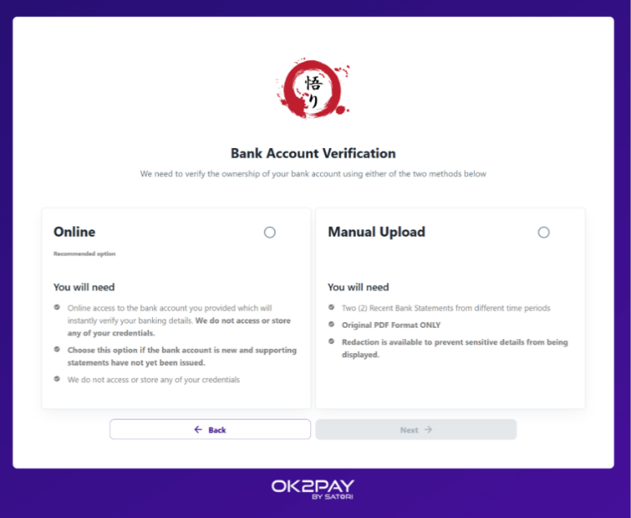
2. Provide your details:
Confirm the company, contact and bank details. You may also be requested to provide some additional information if required.

3. Verify your bank account (choose a method):

Online method (Recommended):
- Securely connect to your bank via a secure platform powered by Credit Sense, a third-party leading consumer and commercial credit bureau, accredited by the Australian Competition & Consumer Commission (ACCC) to provide Consumer Data Rights (CDR) data.
- No credentials are stored; only your account details are verified.
- Instantly verifies your BSB, account number, and account name.

Manual Upload method:
- Upload two PDF bank statements (JPG or other formats are not accepted) from two different months within the last six months. Transaction details may be redacted.
- A verification expert from Satori will call you to confirm the details
Why did I receive an email from Ok2Pay?
CITS has engaged Ok2Pay to verify supplier records. This is a routine process and not related to a specific invoice or payment. If you wish to confirm the legitimacy of the request, please contact the Accounts Payable team directly at accountspayable@cits.wa.gov.au.

Why is this verification necessary?
- Banks do not automatically verify that bank account names match account numbers when processing payments, which can be exploited by fraudsters to redirect funds.

- This verification protects your business and all of CITS customers, ensuring that payments are made securely, timely and accurately.

Why did I receive a phone call from Ok2Pay?
- As part of the verification process, Satori may contact you to confirm your information and ensure your email or systems have not been compromised. Calls are recorded for your protection and audit purposes.

Is there a cost to me?
- No. Verification is free for you.
Is Ok2Pay secure?
- Yes. Ok2Pay adheres to strict security standards and undergoes regular independent security audits to protect your information. The platform is accredited with ASAE 3150 audited assurance report, which means the security of your data is a top priority. Ok2Pay utilises AES-256 and SHA-512 bank grade encryption, leverages two-factor authentication and single sign on, to keep your account and your data secure.

- Additional information regarding Satori’s Ok2Pay can be found on their website: https://satorigrp.com/satori-products/ok2pay.
What happens to my data and bank statements?
- After verification:
- Uploaded documents are permanently deleted.
- Your data is securely stored in Australia under strict access controls.

What is Ok2Pay’s privacy policy?
- You can review Satori’s Ok2Pay privacy policy here: Ok2Pay Privacy Policy

Who can I contact for further information?
- For queries, please contact the CITS Accounts Payable team using the phone number or email provided on the form. Alternatively, you may contact the relevant agency’s business area directly.

