 | Finance Support Team  Email: accountspayable@cits.wa.gov.au  Phone: +61 8 6552 7677  PO Box 8349, Perth Business Centre WA 6849

Supplier (Payee) Creation / Amendment Form

Agency staff use only
Requesting Officer: | Click to enter.
Requester Email: | Click to enter.
Agency: | Click to enter.
New Supplier ☐ | Existing Supplier Update ☐

Note to Suppliers (not applicable to Grant applicants): A “No PO, No Pay” Rule applies to all invoices. Please do not provide goods/services until a purchase order (PO) number has been provided by the agency. All invoices must quote a valid PO number, or the invoice will be returned for amendment.
Note to all Suppliers and Grant applicants: To protect against potential EFT scams and fraud, banking details MUST be confirmed by the supplier/payee as an added security measure. The Department of Creative Industries Tourism and Sport (CITS) and supported agencies (WA Museum, State Library of WA, Art Gallery of WA, Combat Sports Commission, Gaming and Wagering Commission, Racing and Penalties Appeal Tribunal, Department of Local Government Industry Regulation and Safety & Swan Bells Foundation) utilises the services of Satori Australia / OK2Pay to provide verification of bank account, ABN and other details as part of the onboarding process. You will be contacted by a representative to confirm your details. Payments cannot occur until banking confirmations are obtained. Please refer to Ok2Pay Supplier (Payee) verification process on page 3 for further information.
* Mandatory fields must be completed

General
Supplier Number: * | (Agency staff use only)

Trading Name: * | Click to enter.

ABN: * | Click to enter.

ATO Statement by supplier: * | Yes/No | Aboriginal Supplier (Y/N): * | Yes/No
Note: An Australian Taxation Office (ATO) Statement by supplier form is required, if you are a supplier and you are not providing an Australian business number (ABN) on this form.

Supplier/Payee Authorised Officer to confirm bank information (e.g. Accountant, CFO, Treasurer, CEO, etc.)
Name: * | Click to enter.

Position: * | Click to enter. | Phone Number: * | Click to enter.

Email Address: * | Click to enter.

Address: * | Click to enter.

Click to enter.

City: * | Click to enter. | State: * | Click to enter.

Postcode: * | Click to enter.

Secondary Contact Details (if required)
Name: * | Click to enter.

Position: * | Click to enter. | Phone Number: * | Click to enter.

Email Address: * | Click to enter.

Address: * | Click to enter.

Click to enter.

City: * | Click to enter. | State: * | Click to enter.

Postcode: * | Click to enter.

Payment Details
Payment Method: | Electronic Funds Transfer

Bank Account Name: * | Click to enter.

Bank: | Click to enter.

BSB: * | Click to enter.

Account Number: * | Click to enter. | Please include all leading zeros in account

Ageing and Terms
Terms Days: | Click to enter. | (If other than 20 days must be as per a contract)

IMPORTANT – see next page for information outlining the bank verification process utilised by CITS.

Ok2Pay Supplier (Payee) verification process

What is Ok2Pay?
Ok2Pay helps ensure payments from CITS and supported agencies (WA Museum, State Library of WA, Art Gallery of WA, Combat Sports Commission, Gaming and Wagering Commission, Racing and Penalties Appeal Tribunal, Department of Local Government Industry Regulation and Safety & Swan Bells Foundation) are processed securely and reach your correct bank account. It protects against errors and fraud tactics like phishing, fake invoices, and social engineering.

Your participation strengthens the security of your business relationships and protects you from payment disruptions.
How Does the Verification Process Work?
Verification is simple and secure — completed in three steps:

1. Receive the Email:
You’ll receive an email from noreply@prod.ok2pay.co (Ok2Pay) with a secure link to start the process.
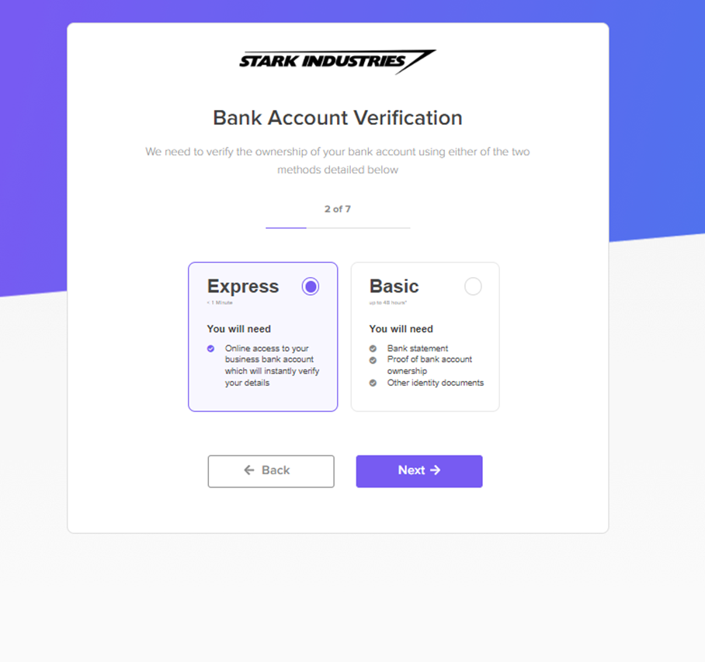
2. Provide Your Details:
Confirm the company, contact and bank details. You may be requested to provide some additional information.

3. Verify Your Bank Account (Choose a Method):

Express Method (Recommended):
- Securely connect to your bank via a secure platform powered by Illion, Australasia’s leading consumer and commercial credit bureau. Illion is accredited by the Australian Competition & Consumer Commission (ACCC) to provide Consumer Data Rights (CDR) data.
- No credentials are stored — only your account details are verified.
- Instantly verifies your BSB, account number, and account name.
Basic Method:
- Upload two bank statements (PDFs only) from two different months in the last six months — sensitive data may be redacted,
- A verification expert from Satori will call you to confirm your details
Why Did I Receive an Email from Ok2Pay?
CITS has engaged Ok2Pay to validate their supplier records — this is a routine process and not linked to a specific invoice or payment. If you wish to verify the request, contact the Accounts Payable team directly at accountspayable@cits.wa.gov.au.
Why Is This Verification Necessary?
Banks do not check that bank account names match account numbers when processing payments. Fraudsters exploit this weakness to redirect payments.
Verification protects both your business and all of CITS’s customers, ensuring payments are made securely, timely and accurately.

Why Did I Receive a Phone Call from Ok2Pay?
The team at Satori / Ok2Pay may call you as part of the verification process to confirm your information and ensure your email or systems haven’t been compromised. Calls are recorded for your protection and audit purposes.
Is There a Cost to Me?
No. Verification is free for you.
Is Ok2Pay Secure?
Yes. Ok2Pay follows strict security standards and undergoes regular independent security audits to protect your information.
What Happens to My Data and Bank Statements?
Once verified:
- Any uploaded documents are permanently deleted,
- Your data is stored securely in Australia under strict access controls.

What is Ok2Pay’s Privacy Policy?
You can review Satori / Ok2Pay’s privacy policy here: Ok2Pay Privacy Policy

Who can I contact for further information?
If you have any queries, please contact the CITS Accounts Payable team using the phone number or email listed on the form. Alternatively, you may liaise directly with the business area of the relevant agency you are engaging with.

